<https://ieeexplore.ieee.org/document/8970507>

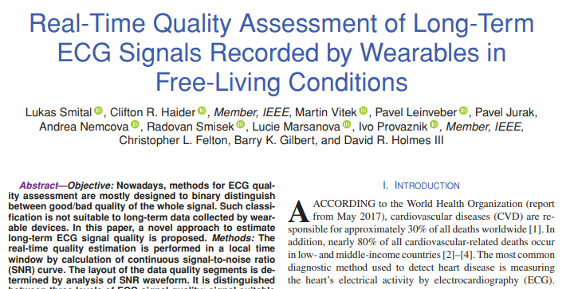

**Significance:** The field of using wearable devices for long term signal monitoring is swiftly developing. No longer is the use of wearable devices limited to short stints in clinical environments. However, with these improvements come massive amounts of collected data. This article discusses how to characterize data in advance to mitigate the time consumed in analyzing the data (prevents unuseable signals from being analyzed)

* Demonstrates ways to get clearer and unobstructed signals in real time environments (free living conditions)
* Pre-conditions data quality to reduce time analyzing large amounts of data
* Although this is in regards to ECG, some of the methods to reduce/characterize data in advance can be applied to our project in a similar fashion
  + positive implications on any wearable sensor, ie limiting analysis to only useable signals

<https://www.ncbi.nlm.nih.gov/pmc/articles/PMC5877384/>

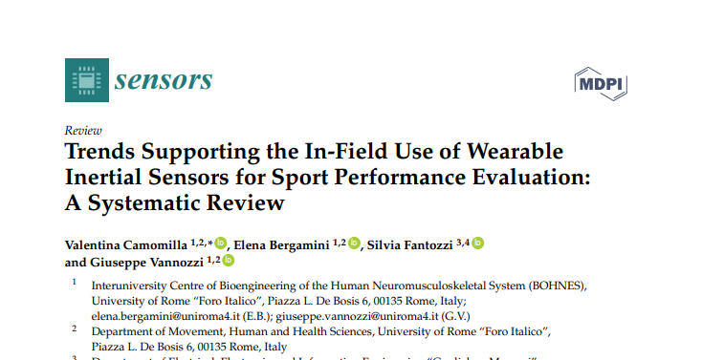

**Significance:** As stated previously, recent technological developments have led to the production of (“*inexpensive, non-invasive, miniature magneto-inertial*”) sensors that are ideal for recording movement data. This movement data in turn is analyzed to provide information on how best to improve performance. This article provides a systematic review of current journals/articles that relate those sensors and their use sports performance evaluation. This article compiles 2040 papers from various sources. What I find most interesting of the 2040 papers that reference the use of wearable sensors to analyze sport related tasks only five out of the 2040 (0.002%) involve para-athletes and 3 of the five were paralympic athletes. This demonstrates a lack of awareness/focus on para-athletes. I believe this article can be used to demonstrate a need for the use of wearable sensors in sports performance evaluation for paraathletes.

**PDF in Files of Teams 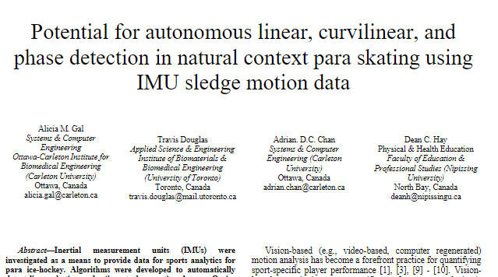 Significance:** A similar journal topic to our proposed project. Shows an ideal location for IMU placement on para skating apparatus. Decent article to look at in regards to background/motivation. Good guideline for expected acceleration expected, to determine what range to expect our device to accept

# **Exploring the Role of Wearable Technology in Sport Kinematics and Kinetics: A Systematic Review**

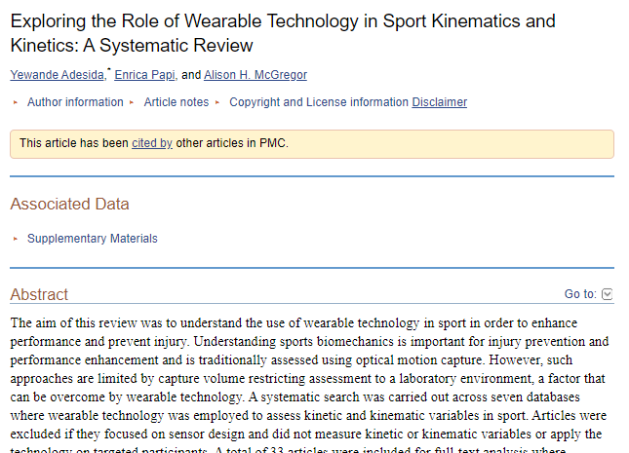

<https://www.ncbi.nlm.nih.gov/pmc/articles/PMC6480145/>

# **The Application of Inertial Sensors in Elite Sports Monitoring**

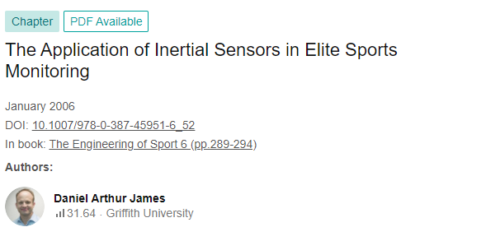

<https://www.researchgate.net/publication/226494653_The_Application_of_Inertial_Sensors_in_Elite_Sports_Monitoring>

MATLAB STUFF

<https://www.mathworks.com/help/fusion/ug/Estimating-Orientation-Using-Inertial-Sensor-Fusion-and-MPU-9250.html;jsessionid=3bd41da0facb1be477e97338fe48?s_eid=PSM_15028>

<https://www.mathworks.com/videos/series/understanding-kalman-filters.html?s_eid=PSM_15028>

<https://x-io.co.uk/res/doc/madgwick_internal_report.pdf>

<https://folk.ntnu.no/skoge/prost/proceedings/cdc-ecc05/pdffiles/papers/1889.pdf>

<http://citeseerx.ist.psu.edu/viewdoc/download?doi=10.1.1.110.5134&rep=rep1&type=pdf>

<https://www.mathworks.com/help/supportpkg/arduinoio/ug/wireless-data-streaming-using-bno055.html>

GOOD INFORMATION

<https://www.hackster.io/neosteam-labs/project-11-esp32-feather-rtc-sd-mk05-cf044a#overview>

<https://learn.adafruit.com/adafruit-adalogger-featherwing/using-the-sd-card>

<https://learn.adafruit.com/data-logging-with-feather-and-circuitpython/circuitpython-code>

<https://www.circuitbasics.com/writing-data-to-files-on-an-sd-card-on-arduino/>

<https://www.link-labs.com/blog/bluetooth-vs-bluetooth-low-energy>

<https://www.youtube.com/watch?v=a6oMN3GRlDQ>

<https://randomnerdtutorials.com/esp32-bluetooth-low-energy-ble-arduino-ide/>

<https://github.com/rebrik/esp32-bno055>

<https://learn.adafruit.com/adafruit-huzzah32-esp32-feather/pinouts>

DEBUGGING

<https://forum.arduino.cc/t/solved-overwriting-a-line-in-a-txt-file-on-an-sd-card/638482>